**GitHub- DevOps B-32**

* Install Git
* Create Directory->and open git bash

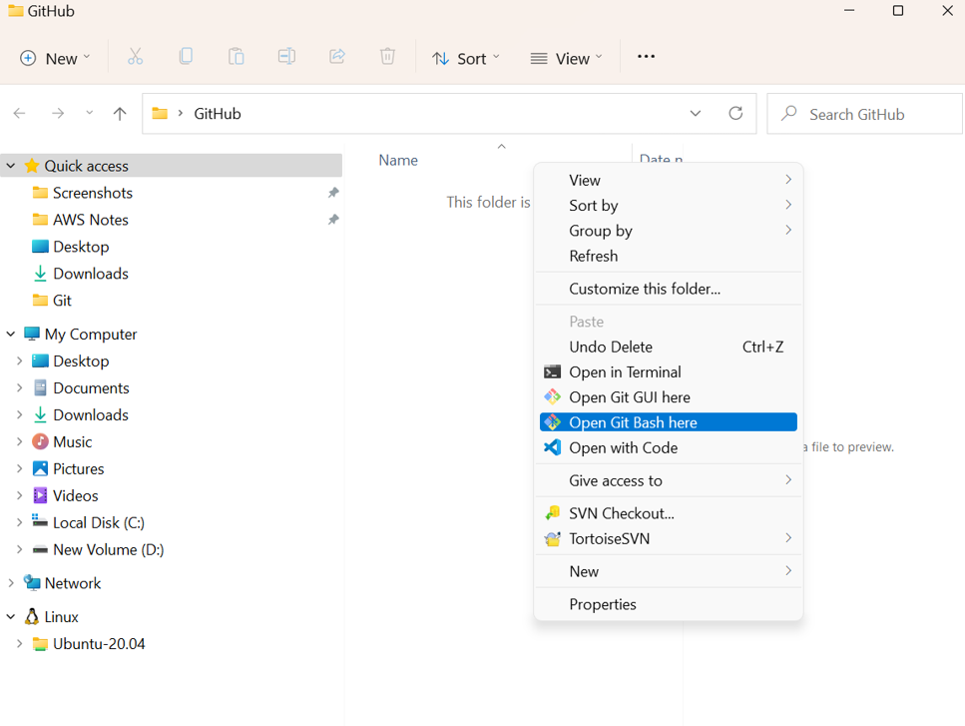



* Go to GitHub Repository and copy URL(https)

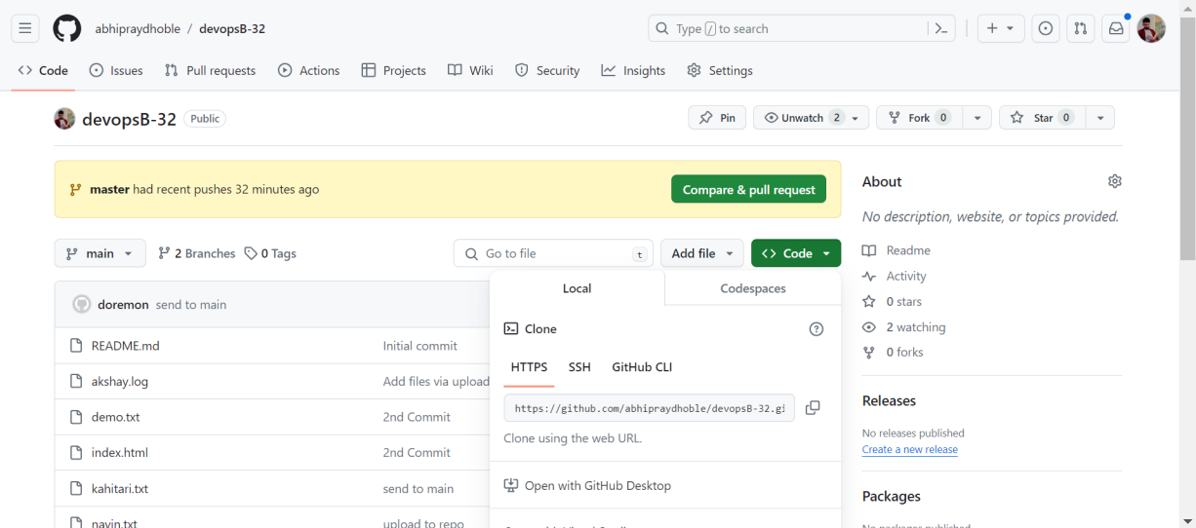



* You can see now our remote repository is clone into our local

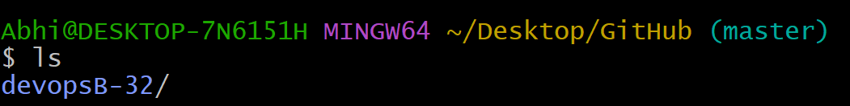

* Lets create one file with name demo.txt



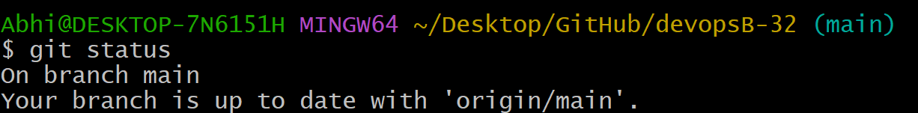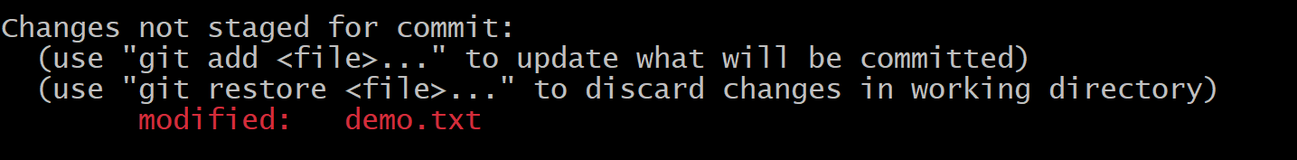

* Commit the final changes



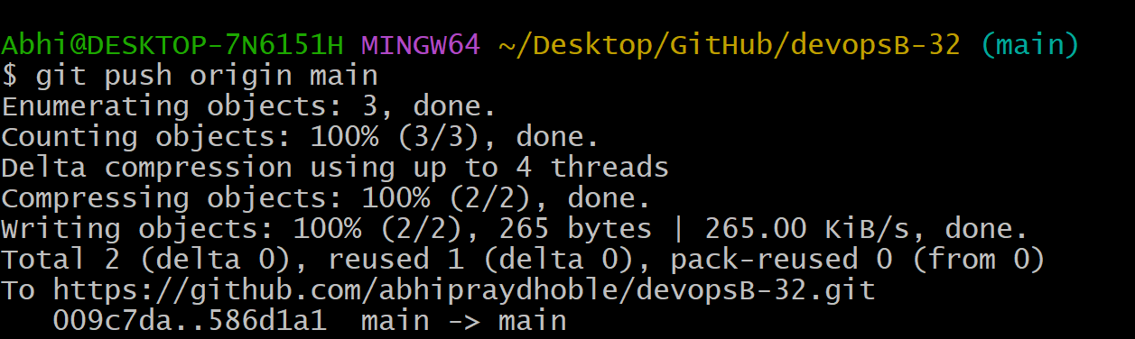

* You can see file is pushed successfully to GitHub repo

